The Writing Life _{by} _{Jodi} _{Rath}
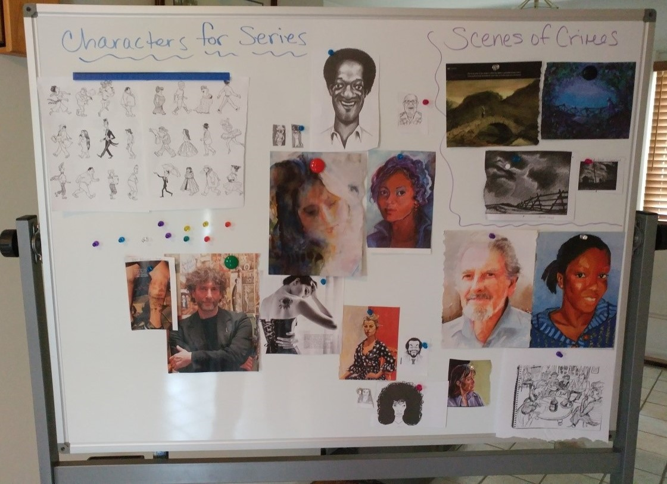
n January 2018, I felt
I
the joy of having my first article published in this newsletter. That seems right seeing that Sisters in Crime and the Guppies are the first writing organi- zations I joined several years ago.
Since then, a lot has hap- pened, beginning with an educational article being published internationally and a collaborative part- nership with two other authors on a three-book deal in education.
From there, I started my own small business, called Mys. Ed—this com- pany combines my two passions of mysteries and education.
Photo courtesy of Jodi Rath

Jodi Rath’s murder board.
While I still am an adjunct instructor in higher education, the ma- jority of my business consists of writing. It seems a bit crazy to
think that back in December 2017, I was writing a first draft (pun intended) for First Draft newsletter about my journey to become a writer and just a few short months later, I now have a business and am writing full time. Hopefully, this will be encouraging to all newbie writers—it is possible. If you remember from the last arti- cle, I mentioned being a five-year-old with dreams of writing. It only took 39 years to reach that dream.
One thing I needed to do to get my writing career going was figure out my process so I could work at a faster pace. In the first article, I mentioned not knowing if I was a pantser or a planner. I’ve since realized I’m a planster (is there such word?). I tend to do best by planning first.

Looking at it visually
I’m a visual person, so when I get stuck on setting, I will go look- ing for a picture of where the protagonist is being kept if they were kidnapped or find a place for the scene of the crime. It helps to have a picture in front of me to give a stronger description.
Jodi Rath is in her 18th year in education. She owns her own business, Mys. Ed, at www.jodirath.com. She is currently collab- orating with two authors on an education- al book on teacher recruitment and reten- tion, and is also working on a cozy mystery series. Find Jodi on Twitter @jodirath.

.
I purchased a large magnetic double-sided whiteboard so I can have the village to my series on one side, keeping me faithful to what the village looks like and where every place is located. On the other side, I have character sketches (literally sketches I’ve
done or found to show me what my characters look like) and plot- ting. I use magnets that allow me to use string to tie clues, red herrings, and plot twists together. My murder board (as I lovingly call it) has been a great purchase and it’s on wheels too, so I can

move it around to wher- ever I’m working. I use
the murder board to begin visual planning, then move onto a brief overall outline.
I took Sally J. Walker’s screenwriting course last November and a para- digm she created was a lifesaver. She gave me permission to share this here (see next page) as long as I included her words: “the paradigm is an amalgamation of para- digms from many re- sources (namely Syd
Field, Chris Vogler, Lajos Egri, and Michael Hague) that I then enhanced to include other essential
storytelling concepts.”
Sally Walker’s paradigm is created for screenwriting, but taking her course really helped me craft the beginning, middle, and end of the story and helped me focus on how to use dialogue to move a story forward. What I like is how this paradigm allows the writer to space out what happens in each section of the story while in- cluding imagery and subplots.
In many ways, this works a lot better for me than a standard out- line. It allows me to create my own visual board on my murder board based on the information I write into this chart. The other great thing is it allows writers to plan an overall story in general or to be very specific with details about the timeline and subplots.
I find that when I get writer’s block, I can return to a combination of my paradigm and visual murder board to move me forward. Maybe I am a complete planner? I feel like once I fill in the para- digm and my murder board, then I’m all set and can write my en- tire story. When I get stuck I go back to one or both of these.
Continued on next page

The Writing Life, continued

What I’ve learned
I have to say that in the last six months of focusing solely on cre- ating a business that is centered on writing, I feel like I’ve learned a lot of things. Here are some of the things that stand out in my mind:
- Don’t stop writing. NO MATTER WHAT. What I mean by that is if you are rejected, then keep writing. If you are accepted, then don’t stop too long to celebrate, but keep writing. This is a competitive business and even when you are accepted
there will always be a line of people waiting for you to fail and to take your place.
- Find your own process. I needed to read what others do, take online courses, and figure out my organizational and writing process. I’m still not completely confident that what I’m doing is completely right for me but the more I write, the more I feel a sense of confidence in my process.
- It is difficult to balance it all. When you are a writer, you ex-

pect to write. Unfortunately, that is only a small part of the job. Every writer has to find a balance of writing, editing, revising, negotiating, submitting, tracking what you are writing and to whom you’ve submitted, marketing, social media, research, and everyday life.
- If you haven’t established a contract with people or publishing companies, it is best to have multiple projects going at once and to be submitting multiple pieces to multiple places to have better chances to get your work published.
- One thing I’ve learned about marketing on social media is
that unless you are a best-selling author, you shouldn’t just sell your writing. It’s best to add personal things two or three
times a week to get people to connect and stay with you, then slip in some information about your work here and there to keep people following you.
One thing I’m excited about is that in six short weeks of my business being “officially” live, I’ve been validated on both the educational side and the mystery side .

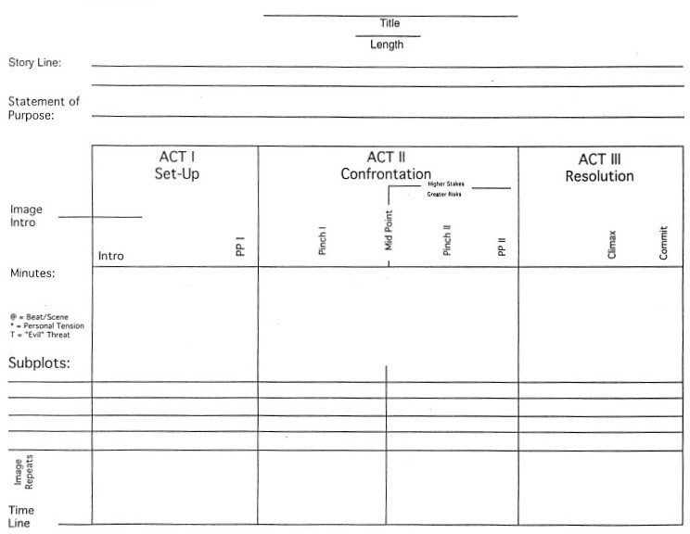
Sally Walker’s paradigm sheet.

